

**AWS RDS documents**

IN this document explaining how to create Mysql, Mssql, databases using AWS RDS service.

RDS used to create different databses like mysql, mssql, oracle, but oracle, arora db paid remaining databases free tier available (one year no need to pay any bill)

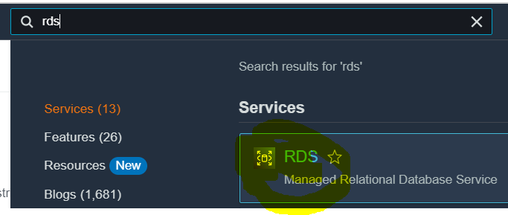

First go to aws serch box and type rds

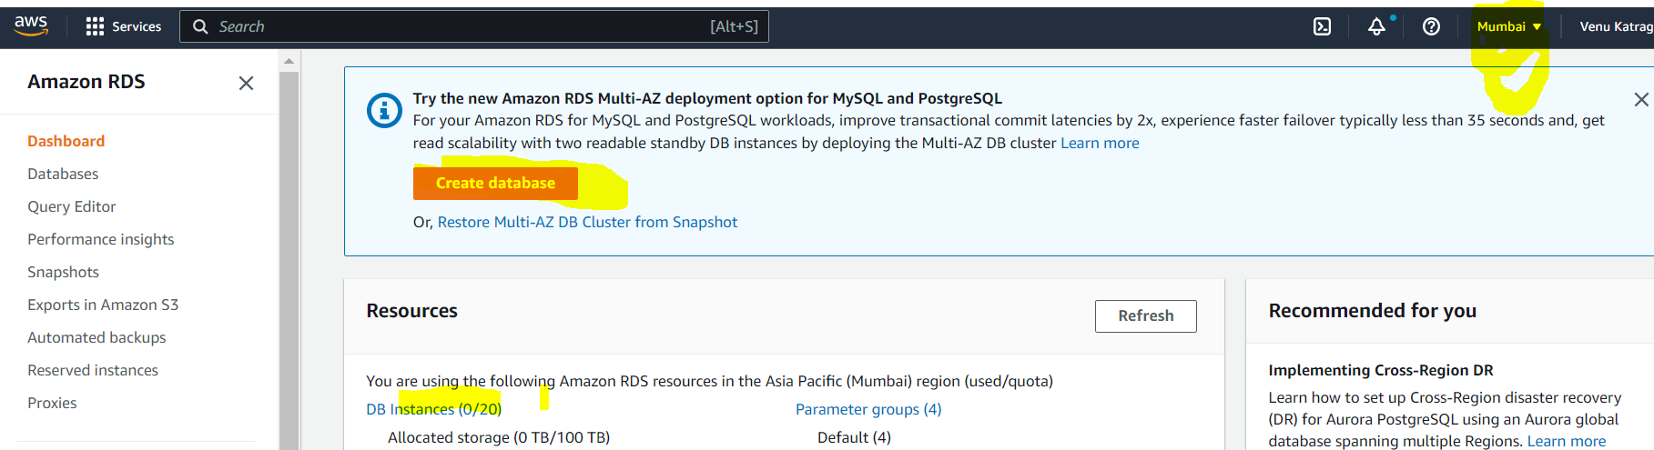

Click on ..

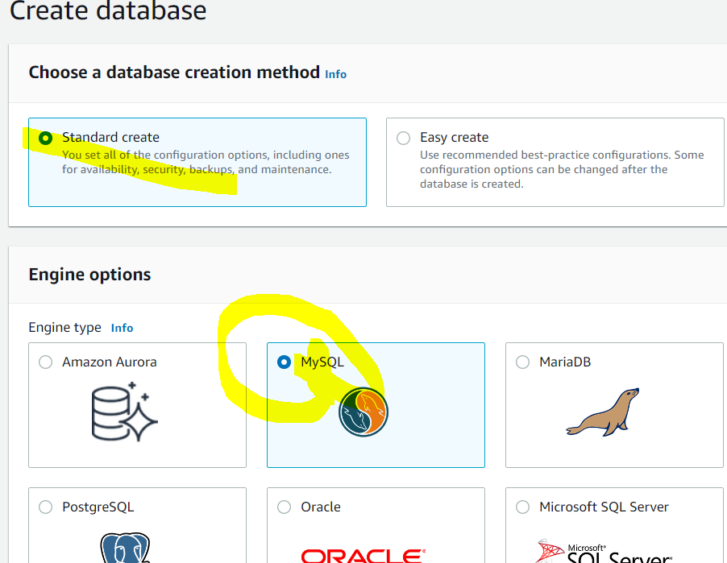

Must choose Free tire only (otherwise u ll get bill)

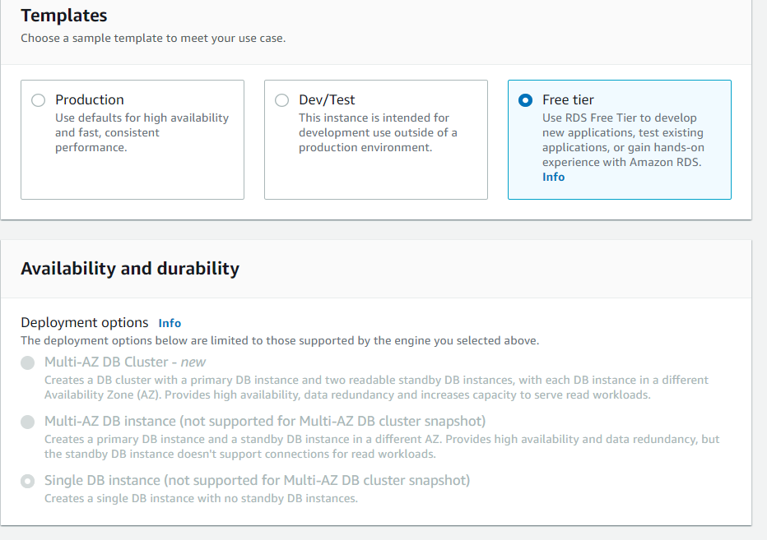

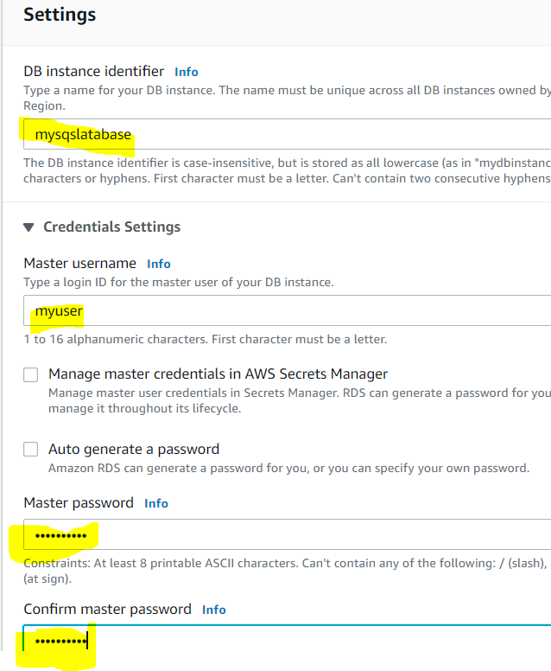

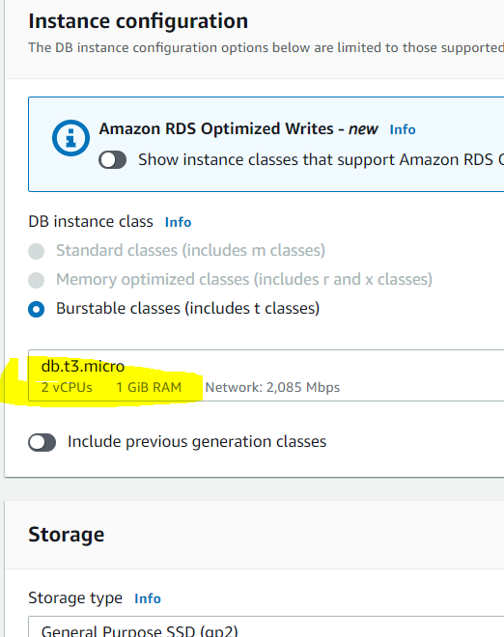

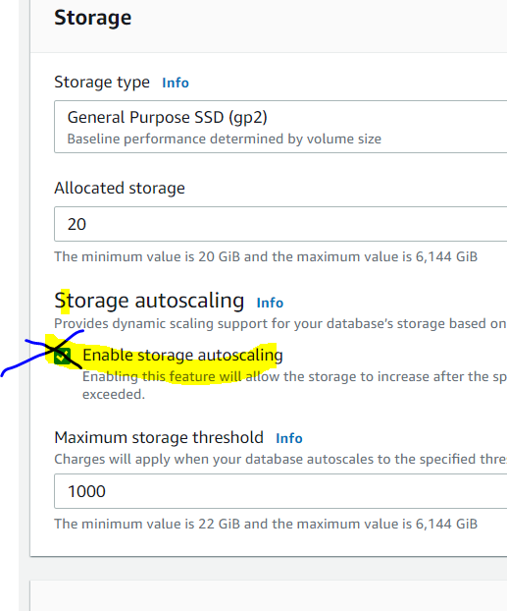

Public access must be yes, otherwise ur unable to access from ur local system.

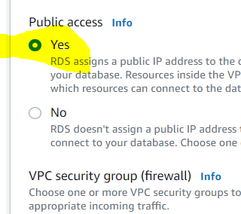

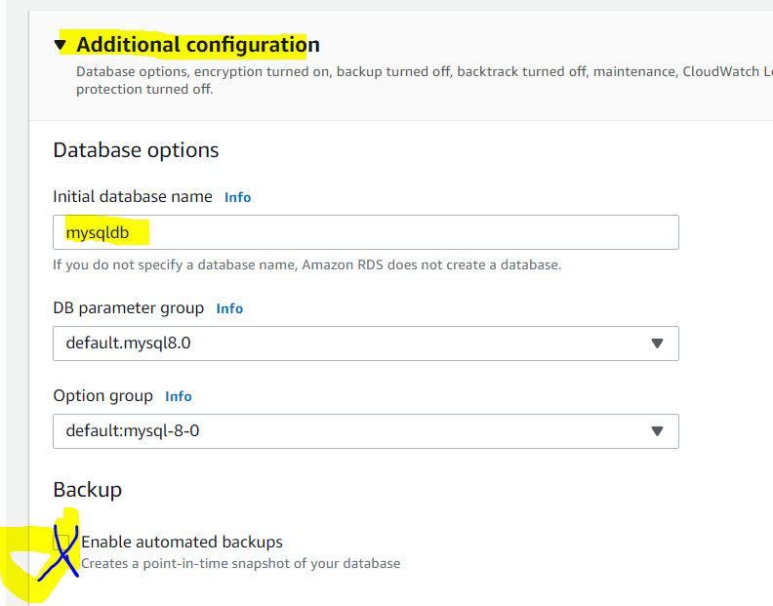

Un check backup... otherwise yu will get bill

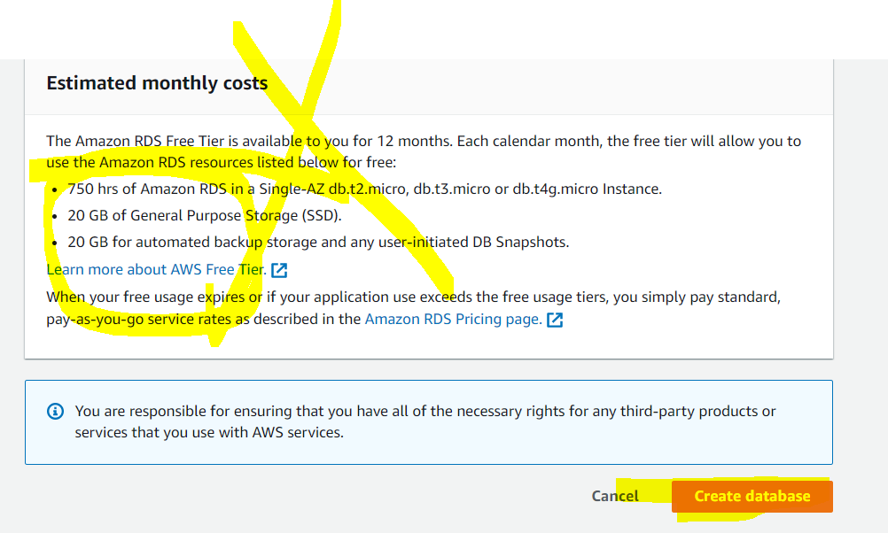

If u get like above there is no any bill.

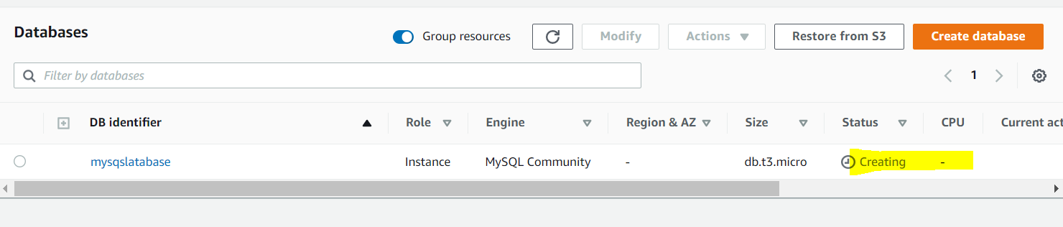

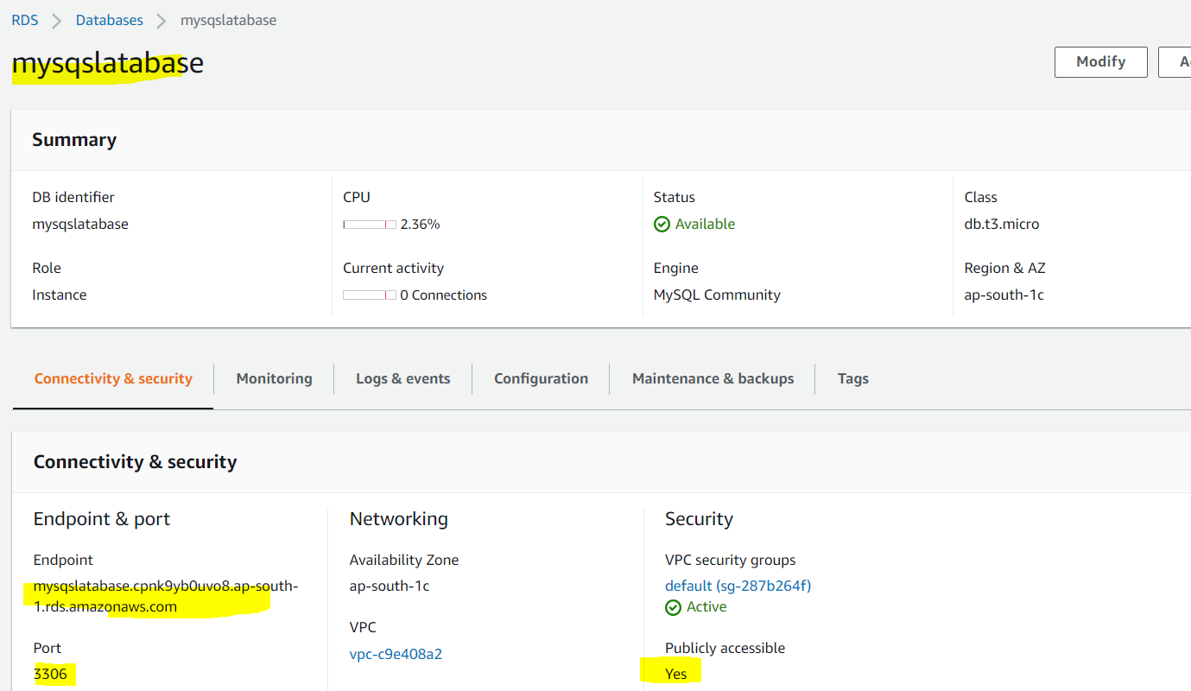

You will get database name you ll get from configuration tab

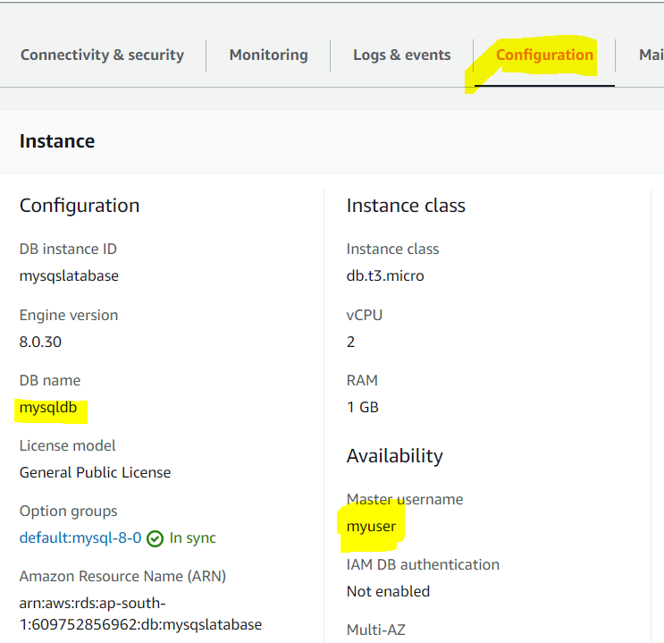

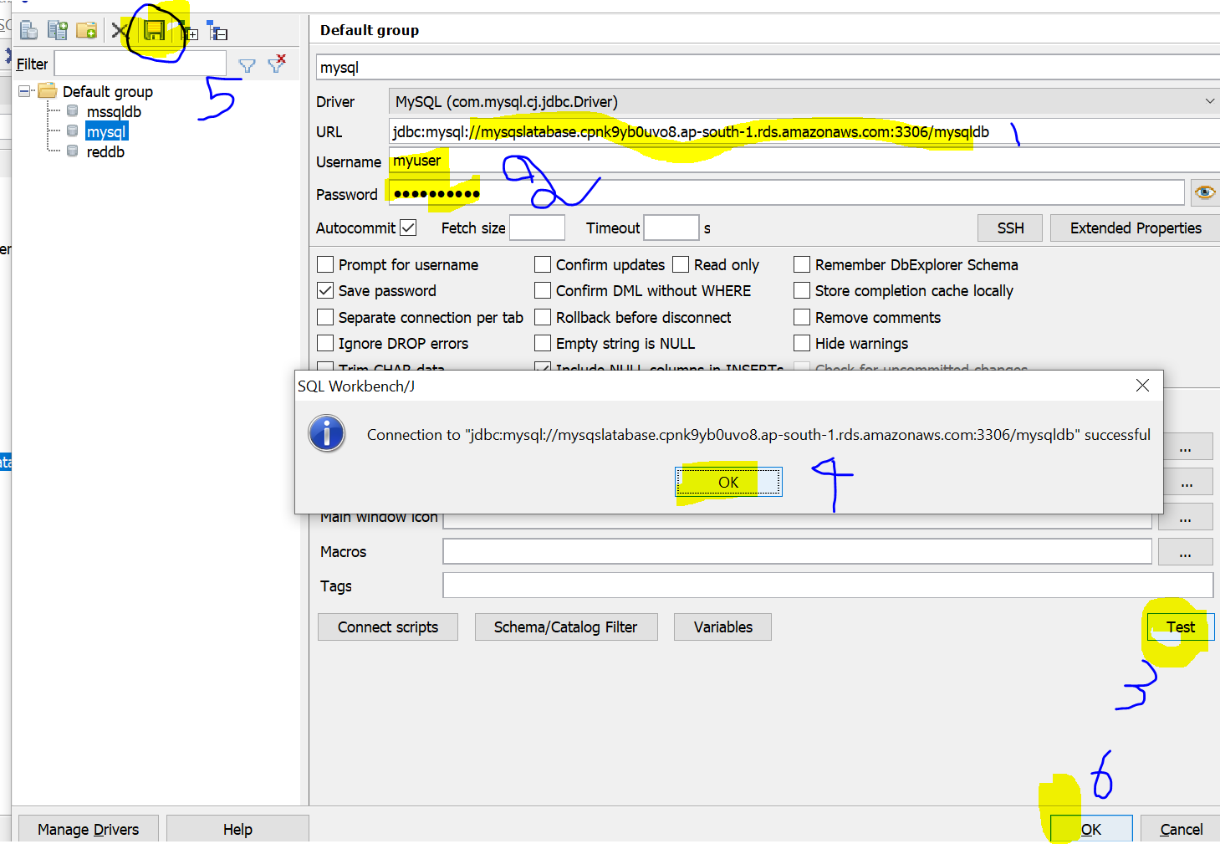

**Hostname**: jdbc:mysql://mysqslatabase.cpnk9yb0uvo8.ap-south-1.rds.amazonaws.com:3306/mysqldb

**Username**: myuser

**Password**: mypassword

How to connect sql workbench follow this video [Connect Oracle Mysql Mssql using sqlWorkbench AWS RDS connect](https://www.youtube.com/watch?v=-l2dGGDMUnU) or <https://www.youtube.com/watch?v=-l2dGGDMUnU>

[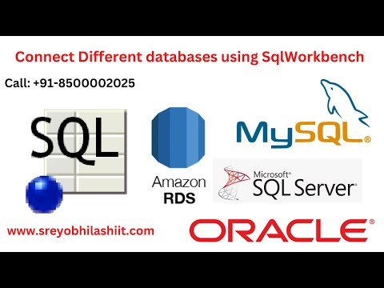](https://www.youtube.com/watch?v=-l2dGGDMUnU)

Pls download this driver folder place in bigdata folder

https://drive.google.com/drive/folders/1R26gs_ekebuwIEHEne96-dnFNiCXcadv?usp=share_link

For more details

It will take little time to create max 5 minutes...

To connect this database you must have different tools using Sql workbench or dbViewer

Please follow this video to configure

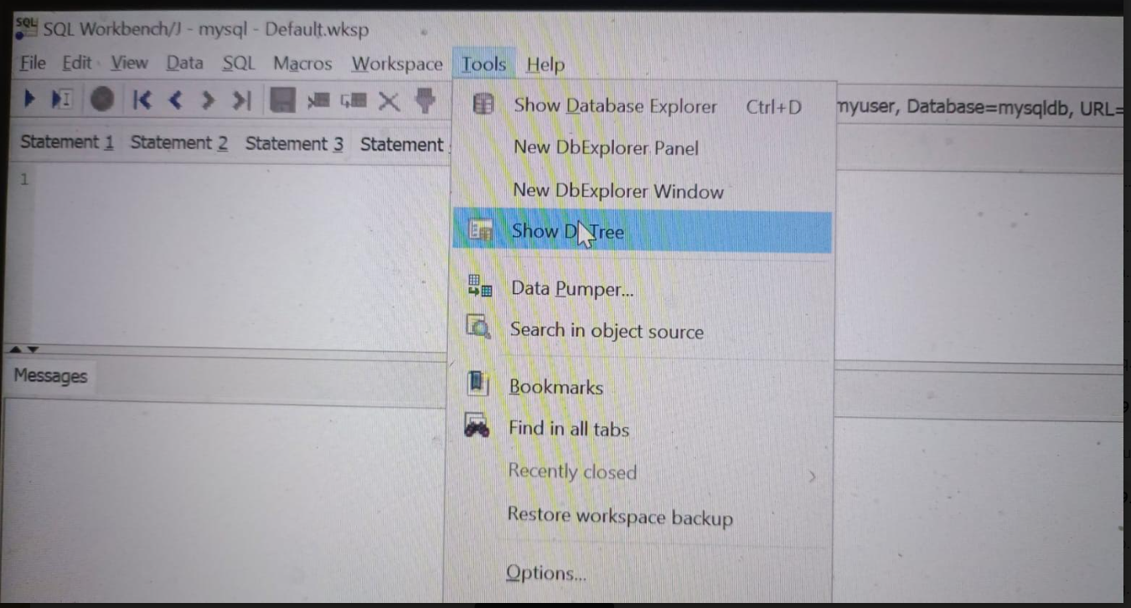

<https://justinsomnia.org/2009/04/the-emp-and-dept-tables-for-mysql/>

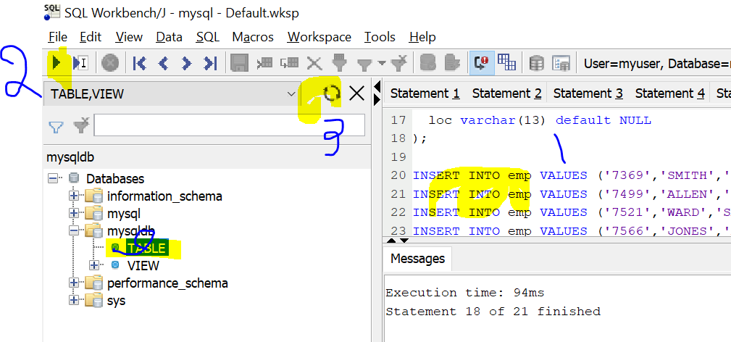

Now create MSSQL database

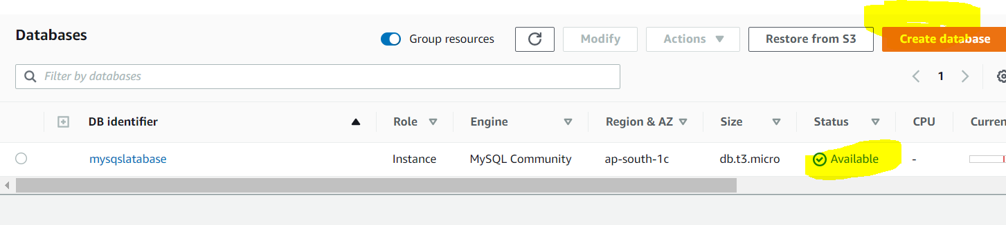

Must choose **Easy create** only

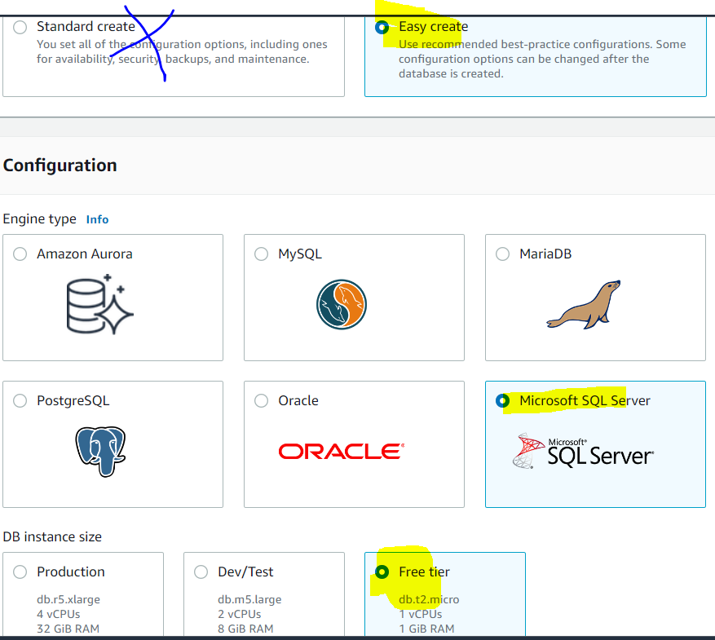

Now create mssql database using these credentials

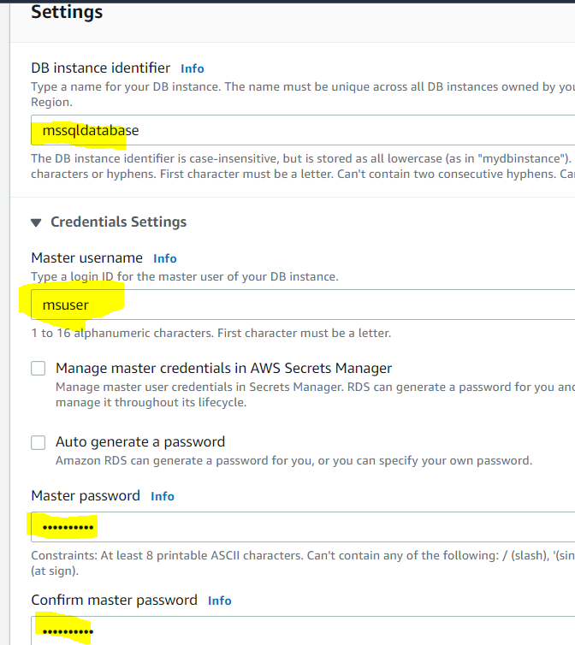

Like mysql if u want to modify everything in freetire is not possible not recommended.

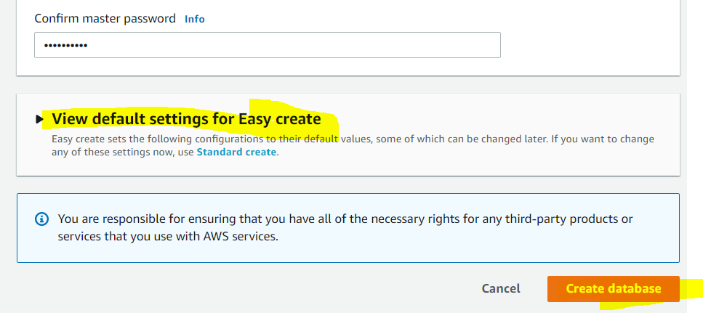

Usually it will take 15 minutes to create database.

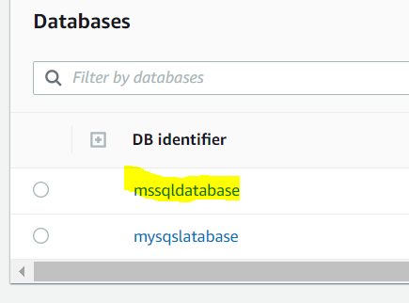

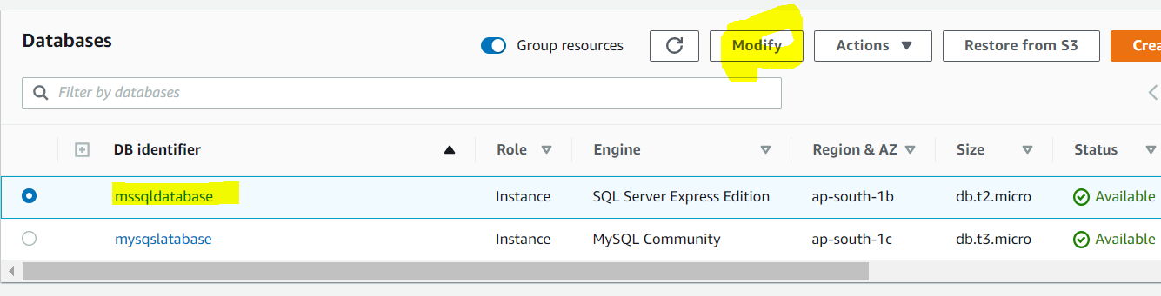

Pls go to moidfy ...

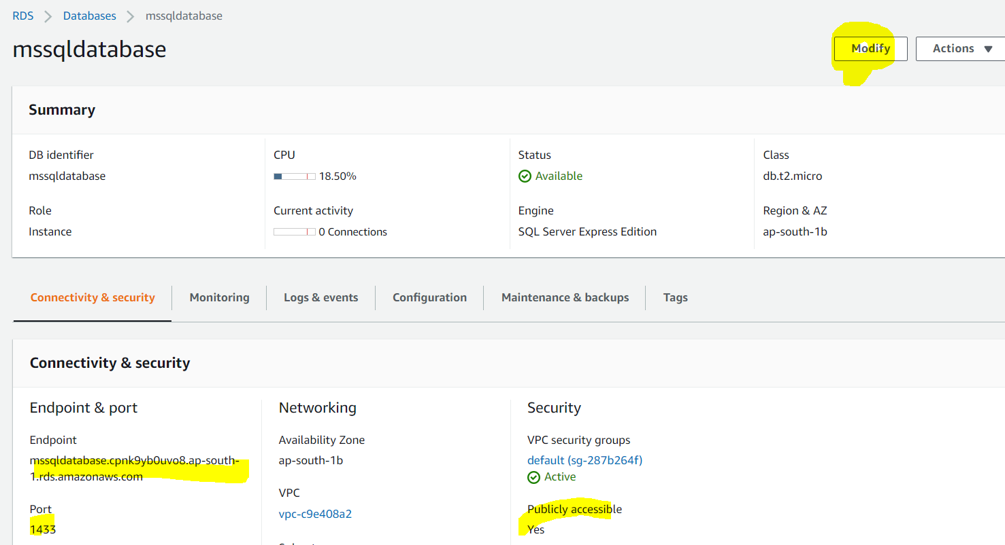

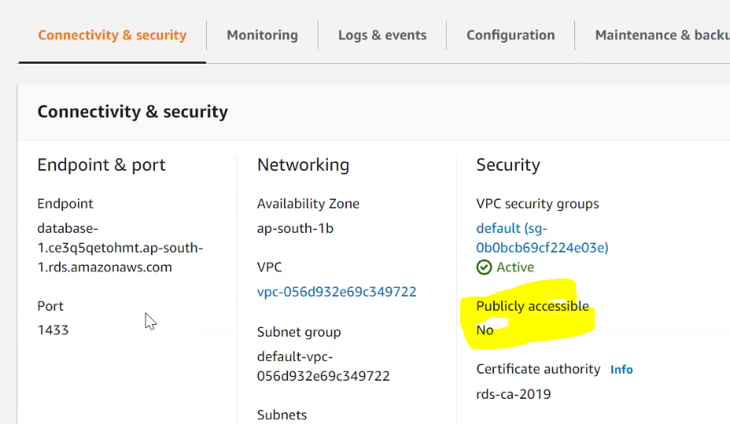

Next scroll down click on Additional configuration Must choose public accessible otherwise ur unable to connect

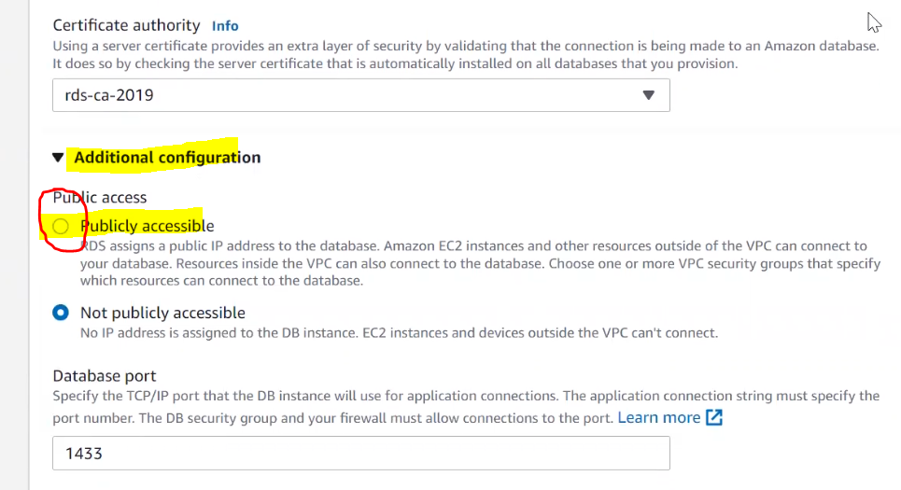

If public access is No, ur unable to connect database so change to yes

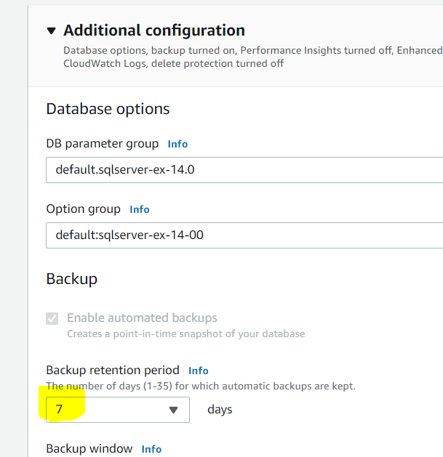

If u take back up for every 7 days ull get bill so change to 0 (means no backup)

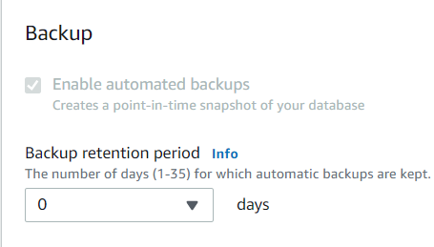

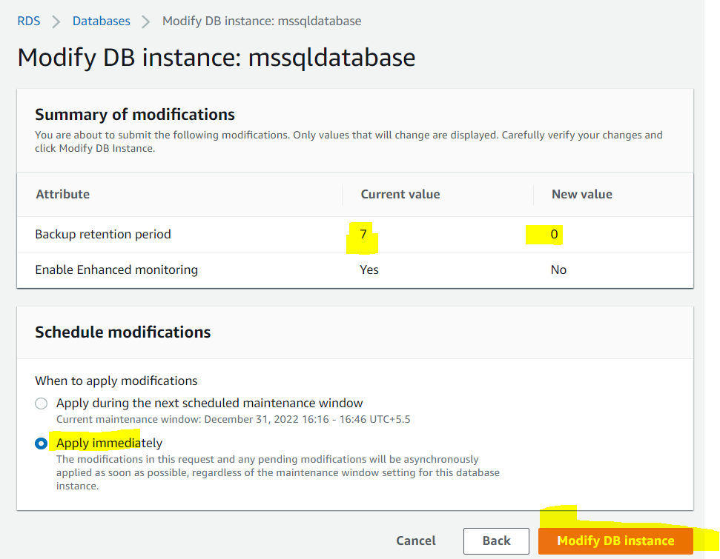

If u choose apply immediately it’s reflected immediately, otherwise it ll take to reflect little tile (TTL) to apply ur settings.

Now connect



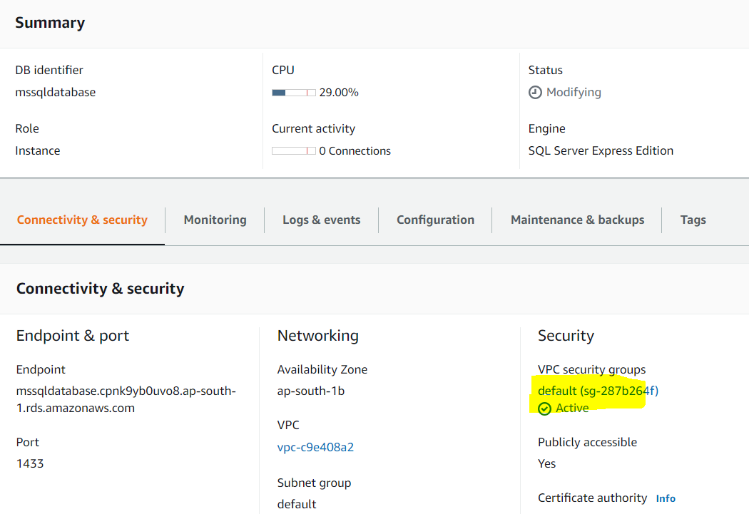

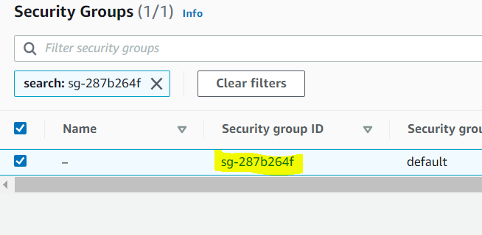

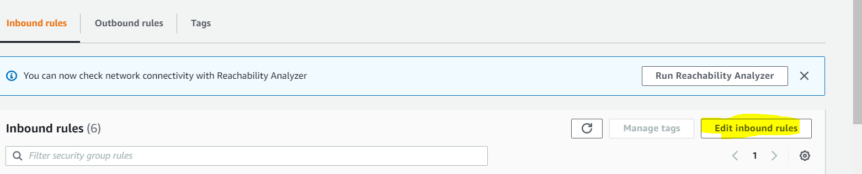

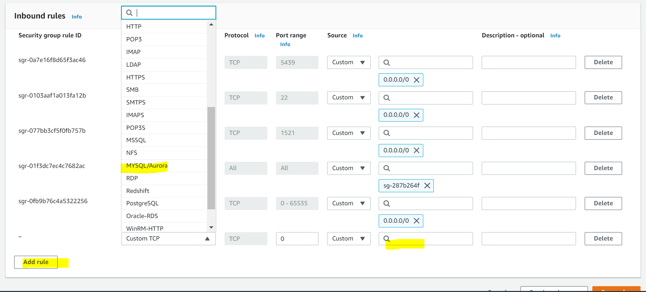

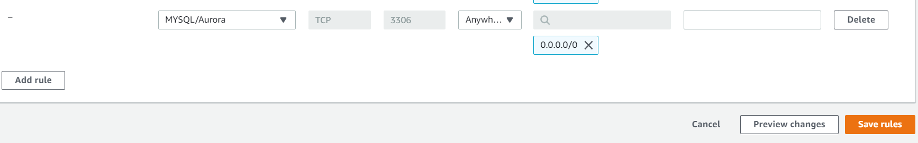

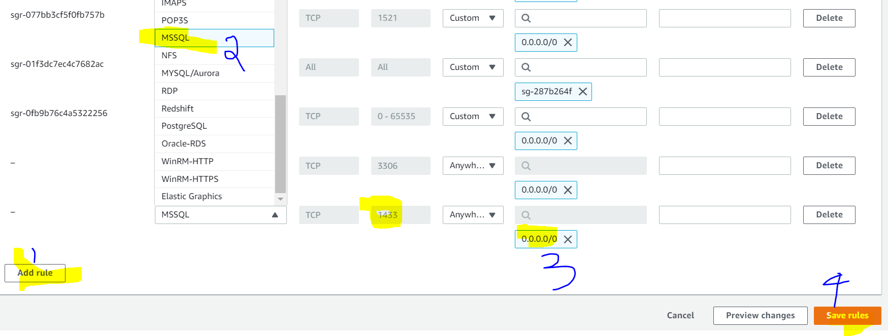

Mysql and mssql ports add in group that only u can access

If you are unable to connect use that... in 7 th page first pic shows how to connect.

**Usually 2 reasons to unable to connect 1) public accessable ..no (change to yes) 2) security group mysql (0.0.0.0/0)**

Usually if u maintain multiple databases u ll get bill in future

So it’s recommended to terminate one instance and maintain one database only.

Like this

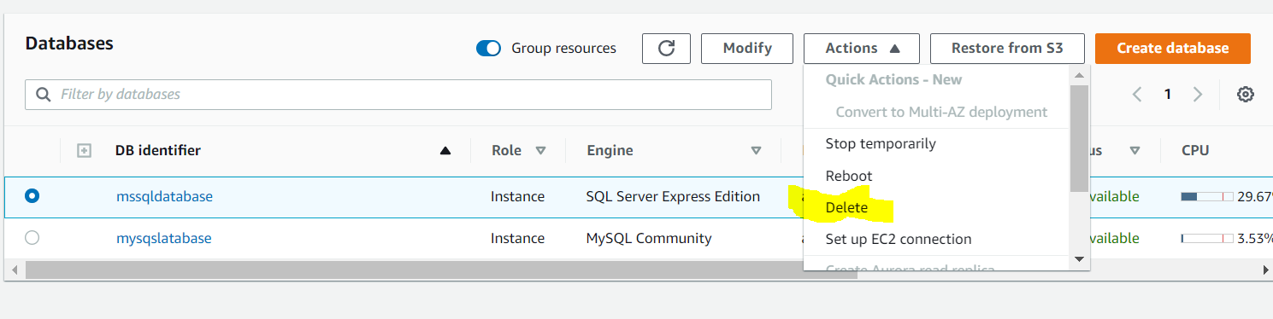

If u take final snapshot u ll get bill. So uncheck that..

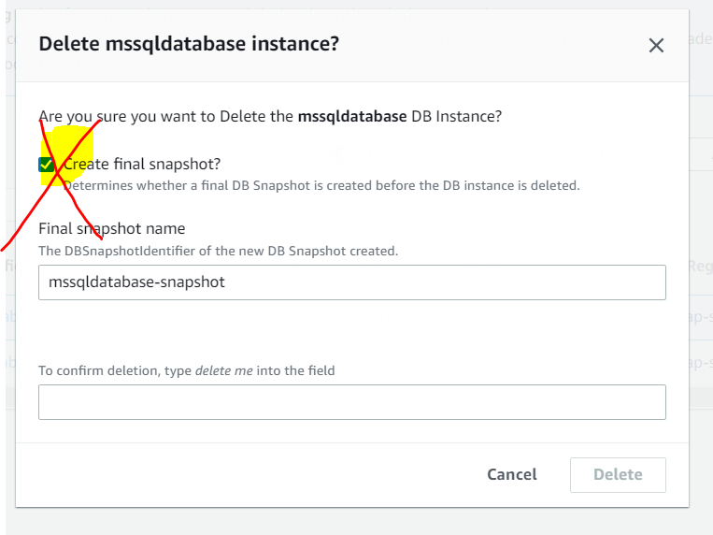

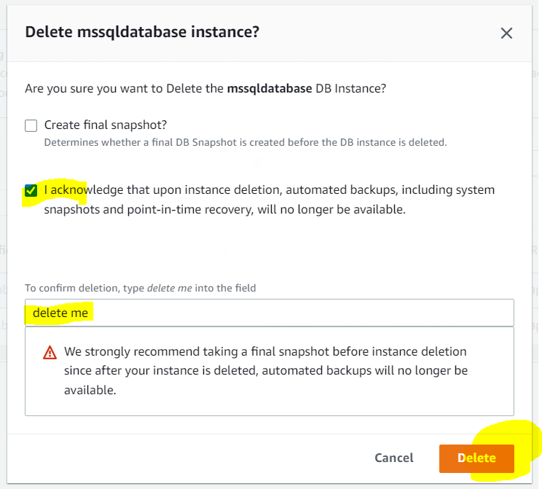

Please check snapshots if u have any snapshots please delete that snapshots otherwise you will get bill.

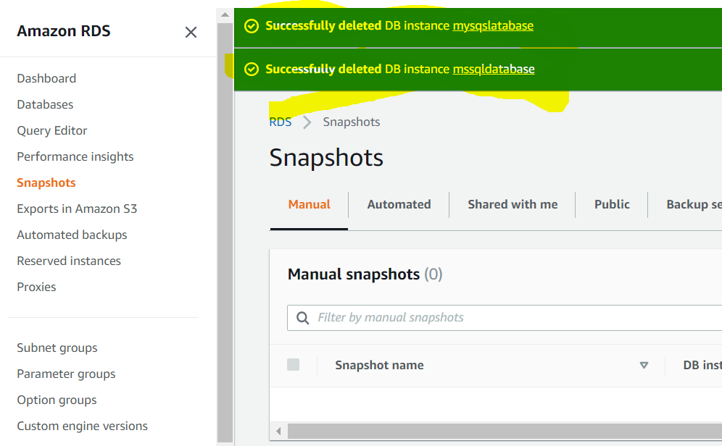

If u have snapshots like this pls terminate it

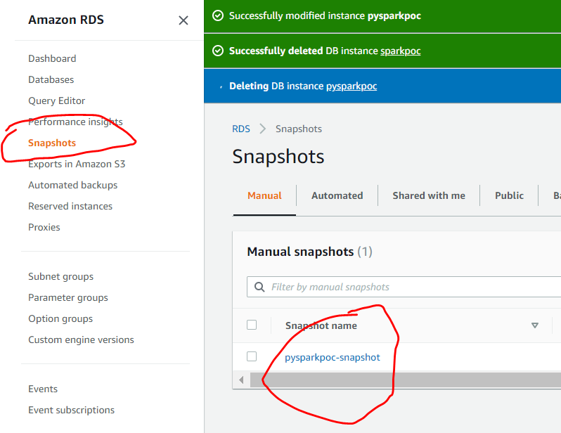

Pls terminate otherwise u ll get bill

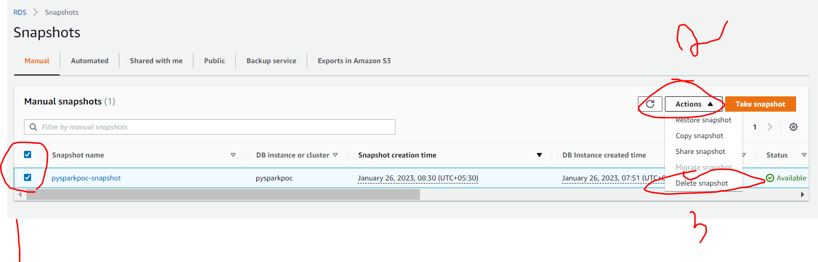

So in future there is no any bill now. The main reason all snapshots deleted.

